PIEZOELECTRIC FOOTSTEPS POWER GENERATING SYSTEM
TEAM MEMBERS
- DHANUSIYA A
- SHRINITHI K M
- NADHIYA G

BRAINSTORMING REPORT

The brainstorming session was conducted to explore innovative approaches for developing a practical energy harvesting system using available resources and emerging technologies. The discussion began by identifying areas where energy is continuously lost during everyday human activities. Team members observed that places with heavy pedestrian movement, such as educational institutions, transportation hubs, commercial complexes, and public walkways, experience a constant flow of people throughout the day. Instead of allowing this mechanical pressure to go unused, the team explored the possibility of converting it into a useful form of energy. Various energy conversion techniques, sensing technologies, energy storage methods, and system integration concepts were analysed to determine their suitability for this application. Different sensor options were compared based on sensitivity, durability, ease of installation, and compatibility with a compact floor-mounted system. The feasibility of integrating a rectifier circuit, rechargeable battery, and output indicator was also discussed to ensure efficient energy collection and utilization. Several design concepts were evaluated with respect to simplicity, scalability, maintenance requirements, and practical implementation. Based on these discussions, the team finalized the concept of a Piezoelectric Footstep Power Generating System, as it provides an effective platform for studying energy harvesting technology while combining electronics, renewable energy, and sustainable engineering principles in a single project. The brainstorming process also helped define the overall system architecture, identify the required hardware components, and establish a clear development plan for building a functional prototype.

IDEA PRIORITIZATION MATRIX

EMPATHY MAP
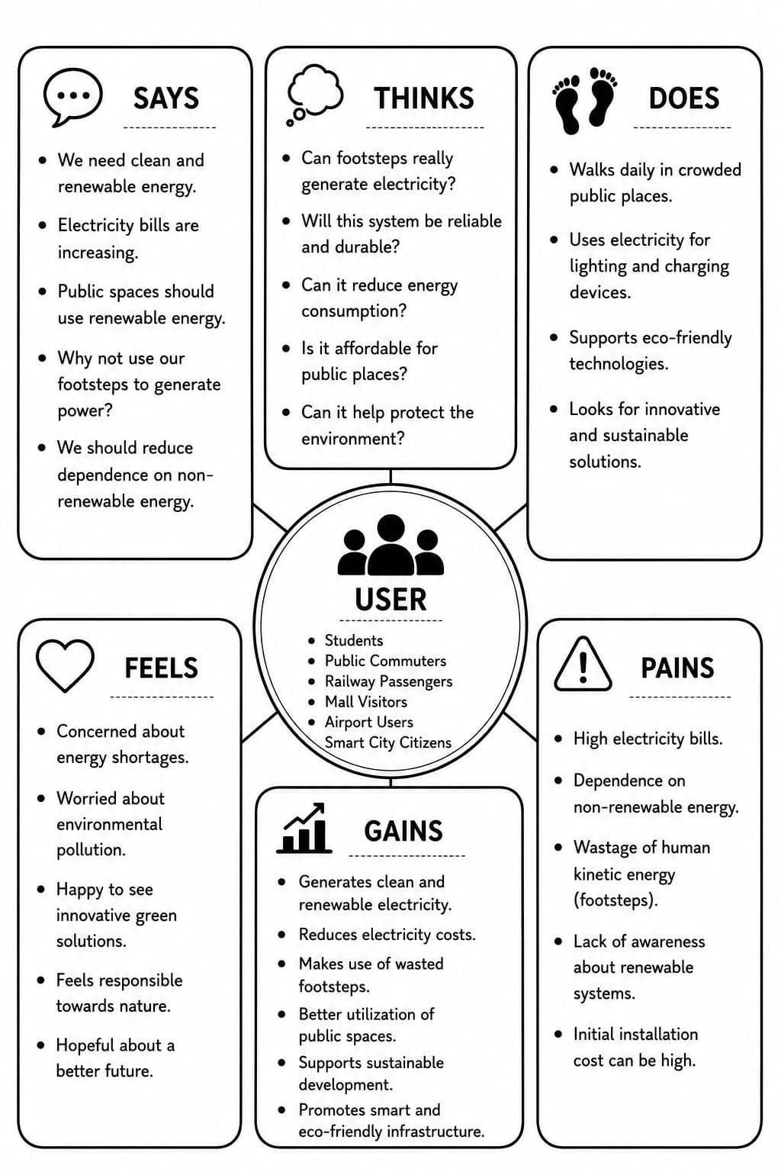
PROPOSED SOLUTION
The proposed solution is to develop a Piezoelectric Footstep Power Generating System with an optimized sensor placement approach to improve energy harvesting efficiency. Unlike conventional systems, where piezoelectric sensors are placed uniformly, this design positions the sensors at the high-pressure regions of the footstep, such as the heel and toe, where maximum force is applied during walking. This arrangement enables greater electrical energy generation without increasing the number of sensors, making the system more efficient and cost-effective.
The electrical energy produced by the piezoelectric sensors is converted into DC using a rectifier circuit and stored in a rechargeable battery. The stored energy can then be used to power low-energy devices such as LED lights, emergency lighting, and sensor-based systems. This solution utilizes wasted human walking energy while improving the performance of existing piezoelectric footstep power generation systems through optimized sensor placement, making it suitable for installation in high-footfall areas such as railway stations, shopping malls, educational institutions, and public walkways.
FUNCTIONAL REQUIREMENTS
- The system should detect high-pressure footstep regions and utilize sensor placement.
- The system should generate maximum electrical energy by placing piezoelectric sensors only at high-pressure points.
- The system should minimize the number of sensors while maintaining efficient power generation.
- The system should convert the generated AC voltage into DC using a bridge rectifier.
- The system should display the generated voltage to provide a stable output.
- The system should store the generated energy in a rechargeable battery or supercapacitor.
- The system should display the generated voltage and battery status on an LCD or digital display.
- The system should power low-power devices such as LEDs or USB charging circuits.
- The system should protect the circuit against reverse current, overvoltage and short circuits.
- The system should operate efficiently under continuous footsteps with optimized sensor utilization.
NON-FUNCTIONAL REQUIREMENTS
- The system shall generate electrical energy efficiently from human footsteps.
- The system shall operate reliably under continuous pedestrian movement.
- The system shall withstand repeated foot pressure without damage.
- The system shall provide a safe, non-slip, and electrically insulated walking surface.
- The system shall minimize power loss during energy conversion and storage.
- The system shall require minimal maintenance for long-term operation.
- The system shall support easy installation in public places such as railway station, malls, and walkways.
- The system shall be cost-effective in terms of installation and maintenance.
- The system shall store the generated electrical energy efficiently for future use.
- The system shall operate in an environmentally friendly and sustainable manner.

PROJECT PLANNING
Duration | Activity
Week 1 | Identify the problem, define project objectives, and conduct a literature review.
Week 2 | Analyze system requirements and prepare the overall system design.
Week 3 | Plan and design the optimized sensor placement for maximum energy harvesting.
Week 4 | Select hardware components and begin prototype development.
Week 5 | Complete prototype assembly and integrate all system components.
Week 6 | Test the system, evaluate performance, and collect experimental data.
Week 7 | Analyze results, optimize system performance, and make necessary improvements.
Week 8 | Prepare the project documentation, finalize the report, and present the project.

RISK ANALYSIS
- Uneven foot traffic may reduce power generation efficiency.
- Incorrect sensor placement can decrease energy output.
- Piezoelectric sensors may get damaged under excessive load.
- Electrical circuit failure can interrupt power generation.
- Battery overcharging may reduce battery lifespan.
- Moisture and dust can damage sensors and electronic components.
- High installation cost may affect project feasibility.
- Lack of regular maintenance can reduce system performance.
- Fluctuating power output may affect connected devices.
- Future system expansion may require additional design modifications.

